
TwitterVane

Installation
Guide

19 February 2013
Contents


Introduction 3
About TwitterVane 3
About this document 3
Where to find more information 3
Contents of this document 3
Getting Started 4
Prerequisites 4
Supported platforms 4
Other platforms 4
Setting up the database 5
Setup using PostgreSQL 8.2 5
Application Server Setup 6
Overview 6
Recommended Deployment Configuration 6
Deploying TwitterVane to Tomcat 7
Configure the Application Context 7
Configure the RMI Connection 7
Configure the Analyser Options 8
Configure the Tweet Stream Options 10
Configure Logging 10
Start the Application Servers 11
Troubleshooting setup 14

Introduction

About TwitterVane
TwitterVane is a tool for leveraging the power of the crowd to select websites for web archiving. It enables curators to define web collections and identify trending Tweets and associated URLs that are relevant to those collections.

About this document
This document is the TwitterVane System Installation Guide. It describes how install, configure and deploy the TwitterVane web application.

Where to find more information
The public resources for TwitterVane, including the source code, binaries and documentation, are available through the TwitterVane Open Source GitHub project:

https://github.com/ukwa/twittervane

Contents of this document
Following this introduction, the guide includes the following sections:
- Getting Started (page 4) — covers prerequisites, supported platforms, other platforms, and optional prerequisites for using TwitterVane
- Setting up the database (page 5)— procedures for setup using PostgreSQL 8.2
- Error: Reference source not found Setup (page 6) — procedures for deploying TwitterVane to Tomcat, includes configuration options and troubleshooting

Getting Started

The following section explains how to get TwitterVane up and running.

Prerequisites

The following are required to successfully install and run TwitterVane:
- Java 1.6 JDK or above
- Apache Tomcat 6.X or above (the application has been tested on Tomcat 6.0.35)
- A Postgresql 8.2 database server.

Supported platforms
The following platforms have been used during the development of the TwitterVane:
- Red Hat Enterprise Linux Server release 6.3 (Santiago).

Other platforms
The following platform was used during the development of the Web Curator tool but is not explicitly supported:
- Windows XP.

Setting up the database

Setup using PostgreSQL 8.2
This guide assumes you have installed and configured Postgresql 8.2 prior to setting up the TwitterVane database and schema.

- Create the database and role:

CREATE DATABASE "twittervane" WITH ENCODING='UTF8';
\c twittervane
CREATE ROLE usr_tv LOGIN PASSWORD 'password' NOINHERIT VALID UNTIL 'infinity';
grant all PRIVILEGES on DATABASE twittervane to usr_tv;

- Generate the database schema:

Run the following scripts using the Postgres SQL command line, psql:

psql –f twittervane –f /twittervane/TweetView/sql/schema.sql
psql –f twittervane –f /twittervane/TweetView/sql/schema_patch1.sql

- The Postgres JDBC driver is included in the GitHub repository (see section: “Where to find more information”) under the /TweetView/lib/ directory.
- The Postgres driver is called postgresql-8.2-507.jdbc4.jar
- The driver will need to be placed into the $TOMCAT_HOME/common/lib/ directory.
- Also required in the $TOMCAT_HOME/common/lib/ directory is the jta.jar

Application Server Setup

Overview
There are three major components to the deployment of the TwitterVane:
- the TweetView component (TweetView.war)
- the TwitterStreamAgent component (TweetStreamAgent.war)
- the TweetAnalyser component (TweetAnalyser.war).

Each of these three components must be deployed for TwitterVane to be fully functional.

The TweetView component provides the management and reporting features that curators use to create and report on Web Collections.

The TweetStreamAgent provides the UI and services for managing the inbound Tweet data from Twitter.

The TweetAnalyser performs URL expansion on shortened URLs associated with a Tweet, resolves a Tweet to a web collection, and manages the storage of Tweets.

All three components can be deployed to different Tomcat instances on a single server or distributed servers.

Recommended Deployment Configuration
The recommended deployment configuration for TwitterVane consists of using a separate Tomcat instance for each of the three components TweetView, TweetStreamAgent and TweetAnalyser.
This isolates application server resources for each component and balances system resources across all components. This means that when one component experiences high load, the other components are not adversely affected.

This also enables the required security constraints to be applied to each component. For example, the TweetStreamAgent and TweetAnalyser management UIs may need to be secured for administrator access only.

Deploying TwitterVane to Tomcat

To deploy TwitterVane to Tomcat:
- Make sure you have installed and configured both Java 1.6 JDK and Apache-Tomcat 6.X successfully.

- Deploy the WAR files into Tomcat. The simplest deployment is to deploy all three WAR files into the same Tomcat container.
- You can copy the WAR files into the $TOMCAT_HOME/webapps/ directory.
- Provided Tomcat is configured correctly, when you start Tomcat the WAR files will be exploded and the application will start.

- Shut down Tomcat once the WAR files have been extracted. This will allow you to modify the configuration files in the following steps.

Configure the Application Context
The curator user interface for TwitterVane is provided by the TweetView component. To allow curators to access TweetView via the URL:

http://servername:port/TwitterVane/

the application context for TweetView must be configured.
Edit the server.xml file in $TOMCAT_HOME/conf and add the following docBase and path properties within the <Host …> element:
<?xml version="1.0" encoding="UTF-8"?>
<Host appBase=”webapps” … >
<Context
docBase="/path/to/tomcat/home/webapps/TweetView" path="/twittervane" reloadable="true" >
</Context>
</Host>

Configure the RMI Connection
The TweetStreamAgent communicates with the TweetAnalyser via Spring RMI and acts as a client. The client connection is configured in the following file:
$TOMCAT_HOME\webapps\TweetStreamAgent\WEB-INF\spring-servlet.xml

<!-- RMI client definition for the tweetAnalyserService --> <bean id="tweetAnalyserService" class="org.springframework.remoting.rmi.RmiProxyFactoryBean">
<property name="serviceUrl" value="rmi://localhost:1099/TweetAnalyserService"/>
<property name="serviceInterface" value="uk.bl.wap.crowdsourcing.agent.TweetAnalyserService"/>
</bean>

Ensure that the hostname value is correct for the “serviceUrl” property.

The serviceURL includes an RMI registry port which is created by the TweetAnalyser. The port is configured in RmiServiceExporter bean in the following file:
$TOMCAT_HOME\webapps\TweetAnalyser\WEB-INF\spring-servlet.xml

<!-- RMI service definition for the tweetAnalyserService -->
<bean class="org.springframework.remoting.rmi.RmiServiceExporter">
<!-- does not necessarily have to be the same name as the bean to be exported -->
<property name="serviceName" value="TweetAnalyserService"/>
<property name="service" ref="tweetAnalyserService"/>
<property name="serviceInterface" value="uk.bl.wap.crowdsourcing.agent.TweetAnalyserService"/>
<!-- defaults to 1099 -->
<property name="registryPort" value="1099"/>
</bean>

Configure the Analyser Options
There are two analyser options that affect how the analysis is processed:

Top Urls
To limit the number of unnecessary URL expansions that are requested from the URL shortener services, a “Top N” optimisation has been implemented. This restricts the number of expansions requested to the “N most frequently occurring” URLs. This limit is controlled by the following configuration option in the above file:

<bean id="tweetAnalyserService" class="uk.bl.wap.crowdsourcing.agent.TweetAnalyserServiceImpl">
<!-- defines the most popular n-URLs -->
<property name="topUrls">
<value type="java.lang.Integer">10</value></property>
…
</bean>

Process Batch Size
When the TweetAnalyser runs, it loads unprocessed Tweets into memory to resolve the Tweet to a web collection and coordinate the URL expansion.
If there are a significant number of Tweets to be processed (ie: 50,000+) the application will exhaust its heap space. To avoid this scenario, Tweets are loaded into memory in batches for processing. The batch size is controlled by the following property in the above file:

<bean id="tweetAnalyserService" class="uk.bl.wap.crowdsourcing.agent.TweetAnalyserServiceImpl">
…
<!-- defines the number of tweets that will be loaded into memory for processing -->
<property name="processBatchSize">
<value type="java.lang.Integer">200</value>
</property>
</bean>

WARNING: Setting the processBatchSize to a high value will cause TweetStreamAgent threads to wait when making the RMI call to trigger the TweetAnalyser. These threads will queue and resume when the analysis completes, causing the TweetStreamAgent to consume more heap space in the interim. This may cause the TweetStreamAgent to exhaust its heap space. It is recommended that the TweetStreamAnalyser is stopped via the admin interface (see: “TwitterVane Administrators Guide.doc”) if the batch size needs to be set to a large value (eg: if, for some reason, all Tweets need reprocessing).

Configure the Tweet Stream Options
There are two TweetStreamAgent options that affect analyser processing and Tweet stream errors:

Analysis Trigger Value
The TweetStreamAgent sends a request to the TweetAnalyser after receiving a specified number of Tweets. This number is specified in the following file:

$TOMCAT_HOME\webapps\TweetStreamAgent\WEB-INF\spring-servlet.xml

<bean id="tweetStreamAgentService" class="uk.bl.wap.crowdsourcing.agent.TweetStreamAgentServiceImpl">
<property name="jsonLogger" ref="jsonLogger" />
<property name="analysisTriggerValue" value="100" />
<property name="displayLastStreamErrors" value="5" />
…
</bean>

Recent Stream Errors
The number of recent Tweet stream errors that are displayed in the admin web interface (see: the “Twitter Stream” section in the “TwitterVane Administrators Guide.doc”) is also configured in the above file. Its value is set by the displayLastStreamErrors
property.

Configure Logging
The log files for each of the TweetView, TweetStreamAgent and TweetAnalyser components are configured in the components \WEB-INF\classes\log4j.xml file for each component.

This file controls the location of the log file and the required logging level (INFO, DEBUG, ERROR etc).

The TweetStreamAgent also writes the content of a Tweet in Json format to a daily Json logfile. The name and location of the Json logfile is configured by the JsonLogger bean in the file:

$TOMCAT_HOME\webapps\TweetStreamAgent\WEB-INF\spring-servlet.xml

<!-- logger to write json tweets to a specified file -->
<bean id="jsonLogger" class="uk.bl.wap.crowdsourcing.logger.JsonLogger" lazy-init="false">
<property name="fileName" value="json" />
<property name="filePath" value="/usr/share/tomcat6/logs/json/" />
<property name="fileExtension" value=".log." />
</bean>

The configuration above will generate Json log files with the following format:
json.log.YYYY-MM-DD
eg:
json.log.2013-02-22

Start the Application Servers
Once the components are configured and the application servers started, each component’s UI will be available at the following URIs:

TweetView:
http://[server]:[port]/TwitterVane/

eg: server=localhost, port=8100

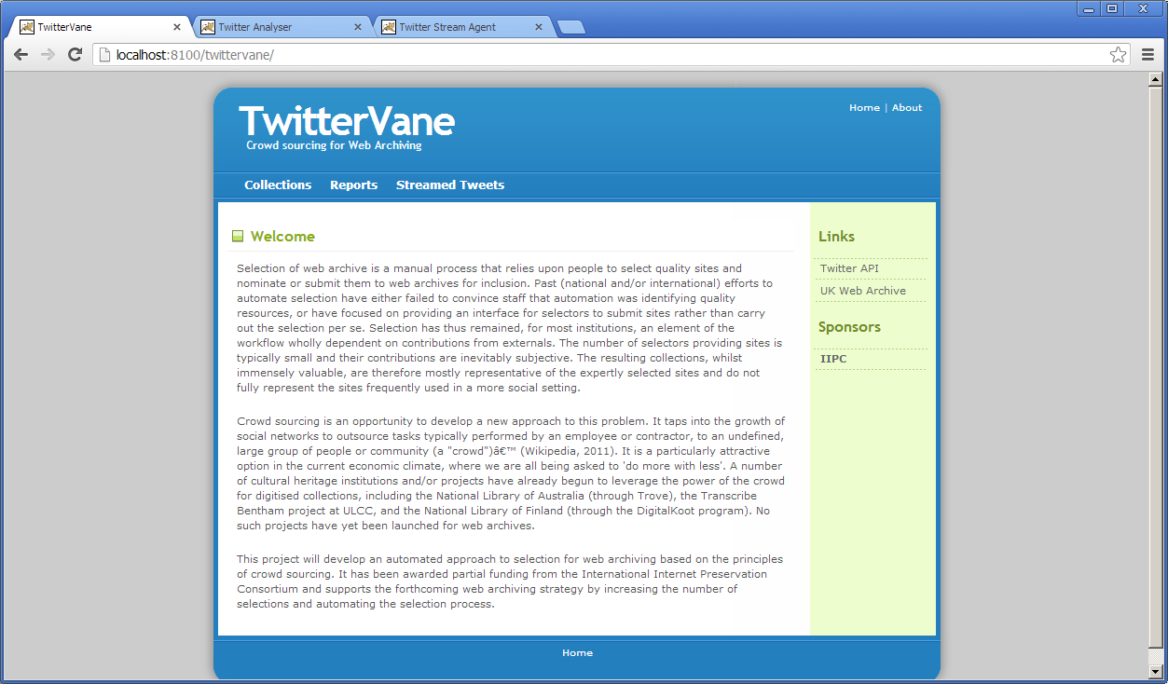

TweetAnalyser:
http://[server]:[port]/TweetAnalyser/

eg: server=localhost, port=8100

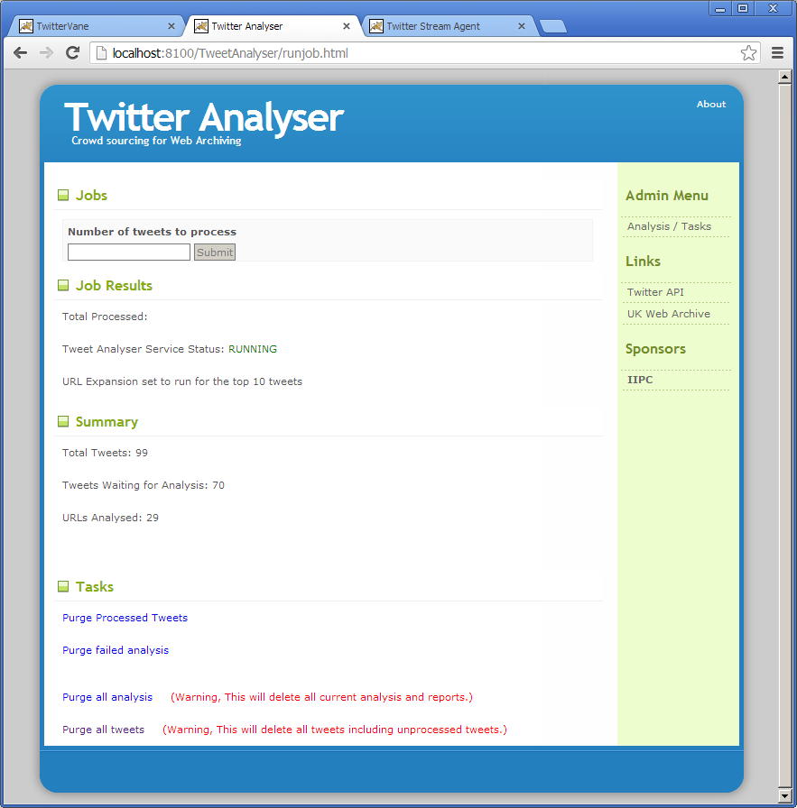

TweetStreamAgent:
http://[server]:[port]/TweetStreamAgent/

eg: server=localhost, port=8200

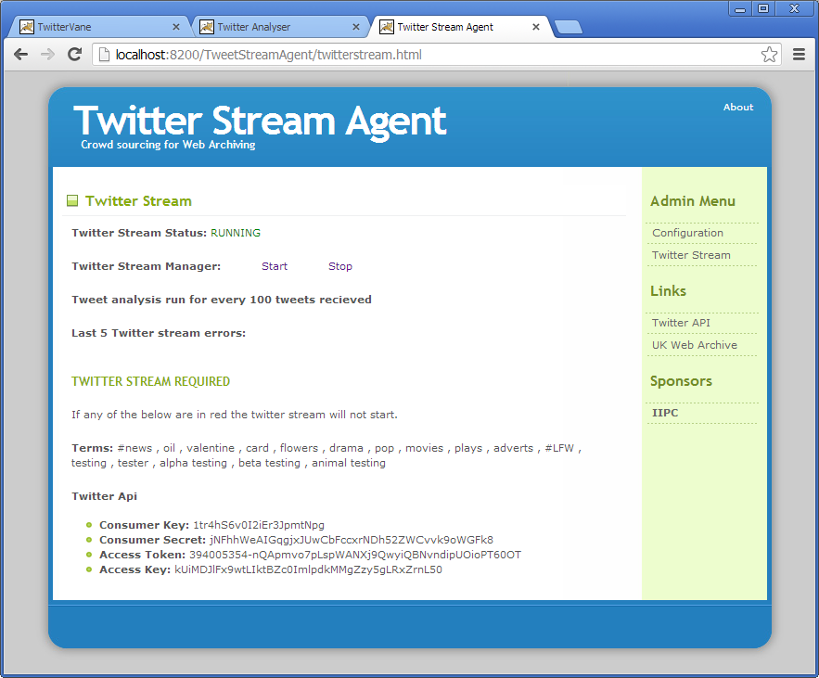

Troubleshooting setup
See the following table to troubleshoot TwitterVane setup.

Problem | Possible solution
Database connection failure | Check that the database connection is defined correctly in the WEB-INF\classes\META-INF\persistence.xml for all three components and that the server can communicate with this host on the specified port.
Connect exception from the TweetStreamAgent | The following exception will be thrown if the TweetStreamAgent is running and the TweetAnalyser component is unavailable (eg: component is stopped, not started, starting or undeployed):  2013-02-22 11:59:28 - Could not connect to remote service [rmi://localhost:1099/TweetAnalyserService]; nested exception is java.rmi.ConnectException: Connection refused to host: 194.66.231.178; nested exception is: java.net.ConnectException: Connection refused: connect  Ensure that the TweetAnalyser component is deployed and has started successfully.  If the exception persists after the TweetAnalyser has started, then the RMI configuration in the “Configure the RMI Connection” section of this guide should be checked for the two components.
Connect exception from the TweetStreamAgent | The following exception is occasionally encountered during the development of TwitterVane:  Invocation of init method failed; nested exception is org.springframework.remoting.RemoteLookupFailureException: Lookup of RMI stub failed; nested exception is java.rmi.NoSuchObjectException: no such object in table  It is caused by the removal of the RMI service class from the JVM running the TweetAnalyser component. This may have resulted from a redeployment of bytecode during debugging, or can be caused by the removal of the class during garbage collection.  In the latter case, disabling garbage collection within the JVM running the TweetAnalyser will prevent the exception reoccurring. The application server running the TweetAnalyser component should then be restarted.
RMI Stub Error | The following exception appears in the TweetStreamAgent log when multiple versions of the Spring Framework are present on the application server classpath:  2013-02-06 13:54:43,980 ERROR [Twitter4J Async Dispatcher[0]] controller.TwitterStreamDaemonController$1 (TwitterStreamDaemonController.java:247) - Transaction error on tweetNo matching RMI stub method found for: public abstract void uk.bl.wap.crowdsourcing.agent.TweetAnalyserService.run(); nested exception is java.lang.NoSuchMethodException: org.springframework.remoting.rmi.RmiInvocationWrapper_Stub.run(), cause: java.lang.NoSuchMethodException: org.springframework.remoting.rmi.RmiInvocationWrapper_Stub.run()  To fix the error, remove the incorrect versions of the Spring jars from the classpath. The correct version for TwitterVane is:  spring-*-3.2.0.RELEASE.jar  The same exception may also be thrown when the following jar is on the classpath:  wayback-hadoop-1.*.jar  This jar should be removed from the classpath if present.

